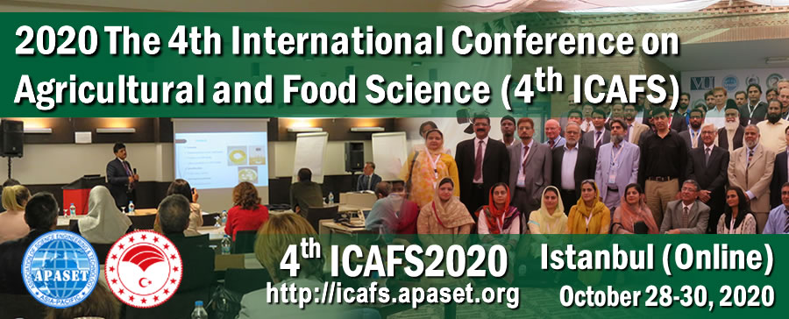

2020 The 4th International Conference on Agricultural and Food Science (4th ICAFS 2020)
On behalf of the organizers, it is our great pleasure to announce that “The 4th International Conference on Agricultural and Food Science (4th ICAFS 2020)” will be held virtually online during October 28-30, 2020.
For more details please visit the website at https://icafs.apaset.org/
It is co-organized by Asia-Pacific Association of Science Engineering and Technology, Bahri Dağdaş International Agricultural Research Institute, in cooperation with multiple academic affiliations.
Previous ICAFS were successfully held in Kuala Lumpur - Malaysia (2019), Istanbul - Turkey (2018) and Lahore - Pakistan (2017). It has been designed to provide an innovative and comprehensive overview of AGRICULTURAL and FOOD SCIENCES. A focus will be given on:
- Plant Sciences; Agronomy, Soil & Environmental Science;
- Food Science, Food Chemistry, Functional Foods and Bioactives;
- Agricultural Ecology, Resources, GIS and Remote Sensing;
- Animal and Livestock Science, Veterinary, Aquiculture and Fishery;
- Forestry Science, Wood Research, Bioenergy and Biomaterials;
- Other related topics and applications in Engineering and Technology, Management, Medicine, etc.
Accepted abstracts will be included in conference abstract book. Selected full papers will be published in IOP Conference Series: Earth and Environmental Science (Print ISSN: 1755-1307 indexed in Scopus, EI Compendex, Web of Science-CPCI) or other related collaborated journals.
Please bring this notice to the attention of any of your colleagues who may be interested in participating the conference. We look forward to an exciting meeting that promises great scientific debate.

ICAFS20 Organizing Committee
Website: https://icafs.apaset.org/
Secretariat Email: icafs@apaset.org; icafs@apaset.edu.kg

